**Developing an E-commerce Website for Sporty Shoes.**

**OUTPUTS:**

**Flow chart:**

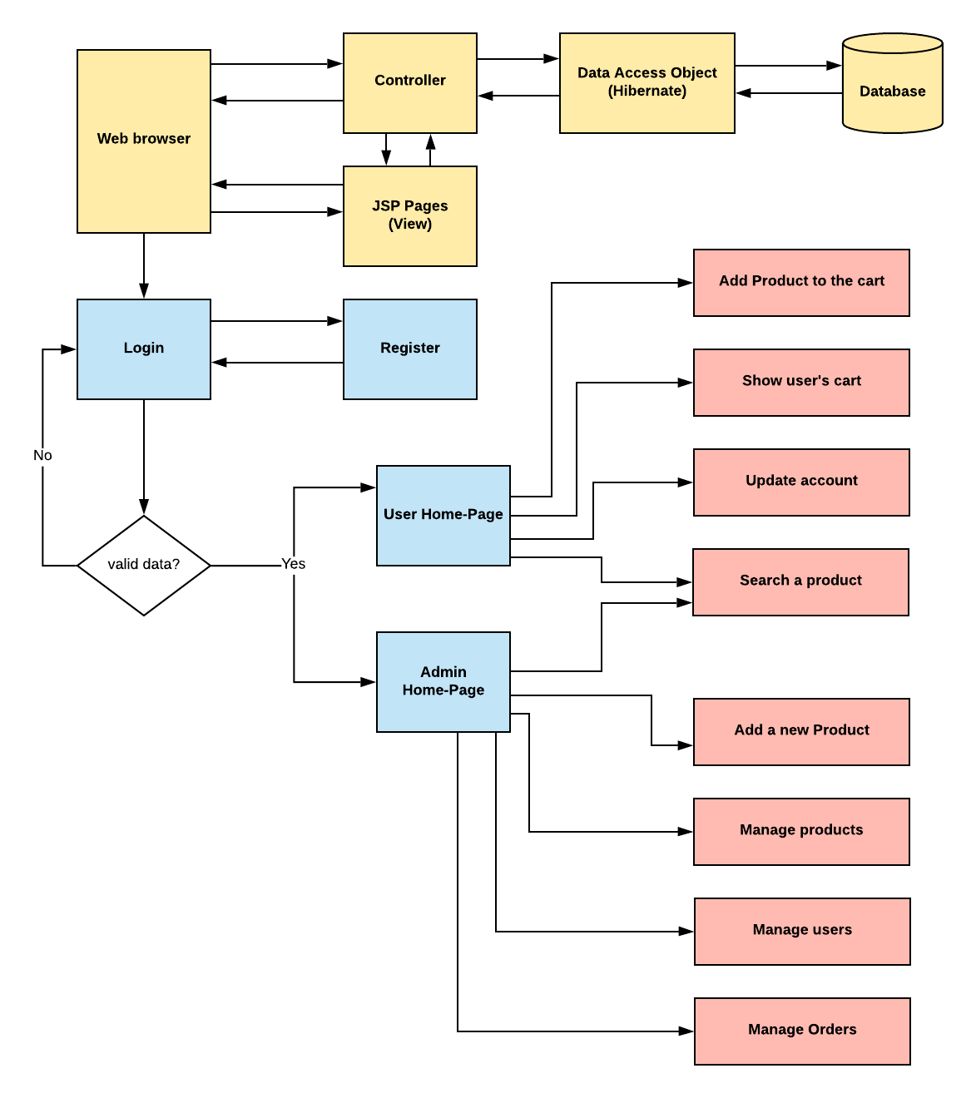

1. **Register page:**

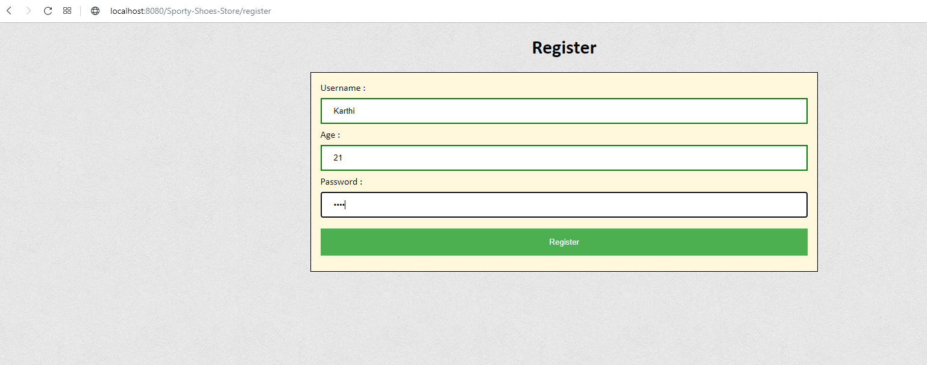

**2. Login page :**

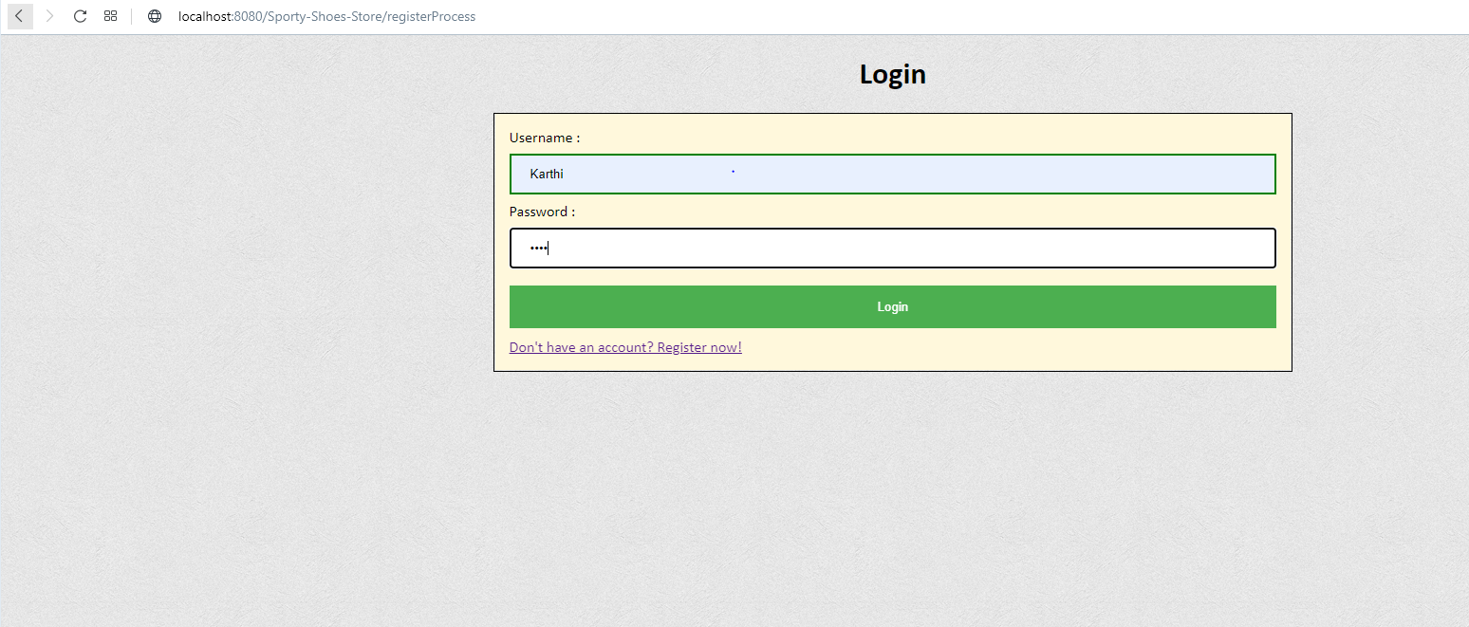

1. **Users home page:**

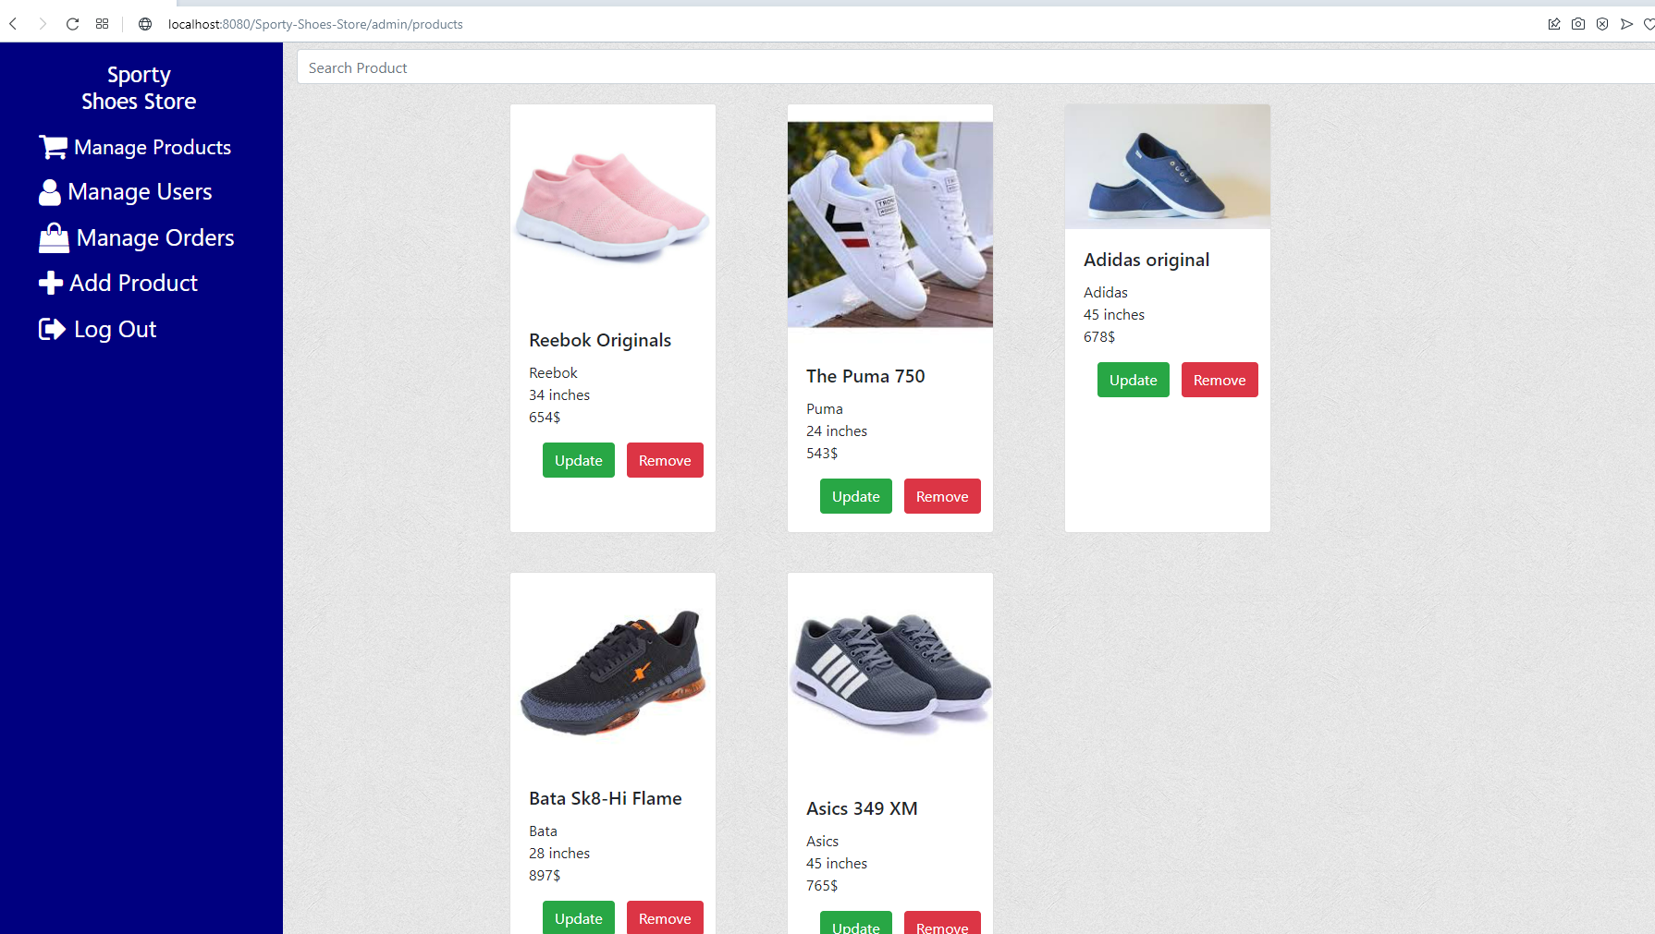

1. **Users cart page:**

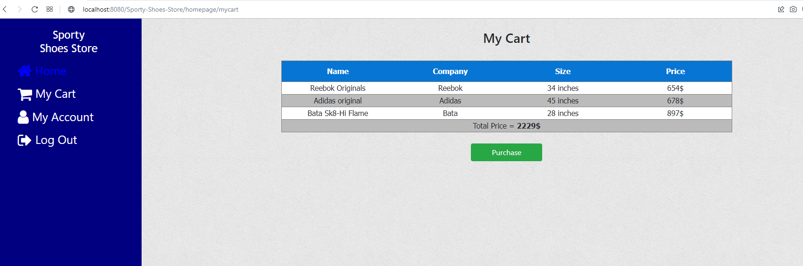

1. **Users update account page:**

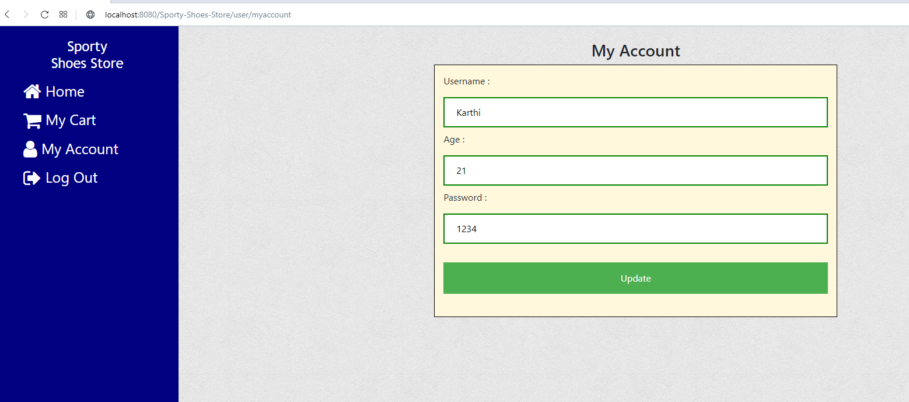

1. **Login as admin:**

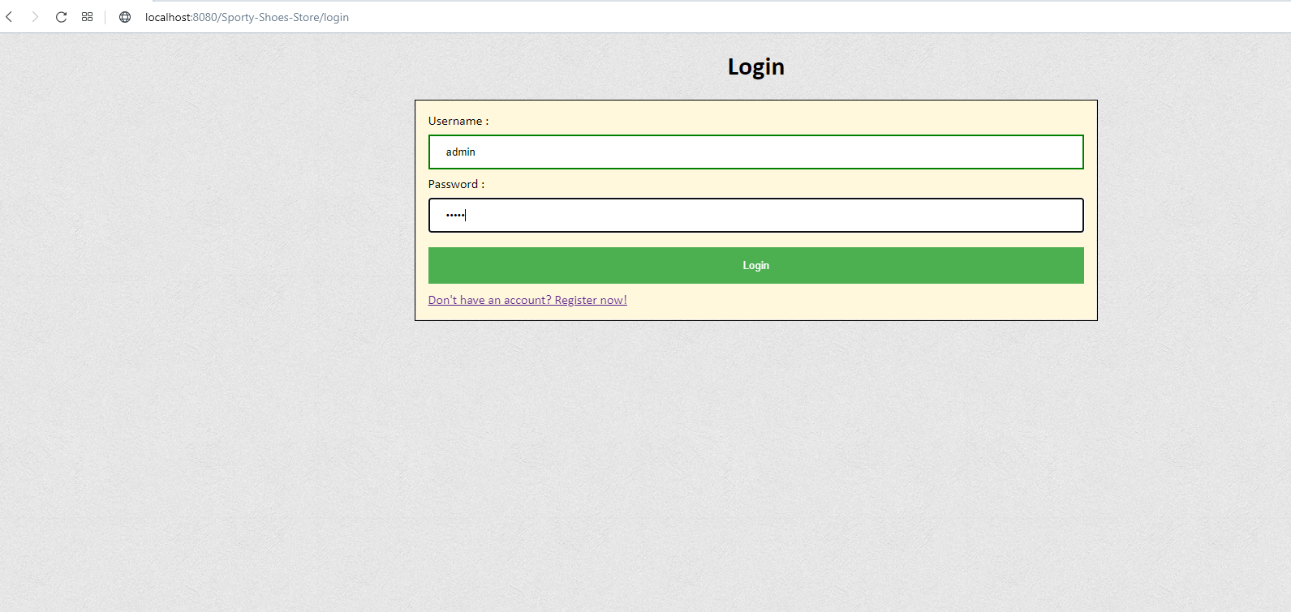

1. **Admins manage product page:**

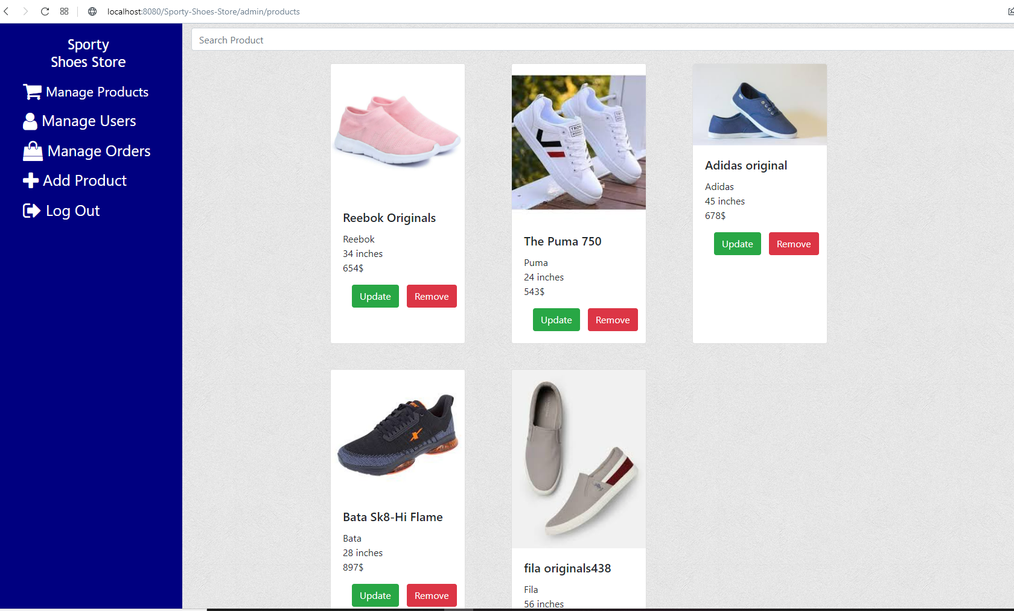

1. **Update products page:**

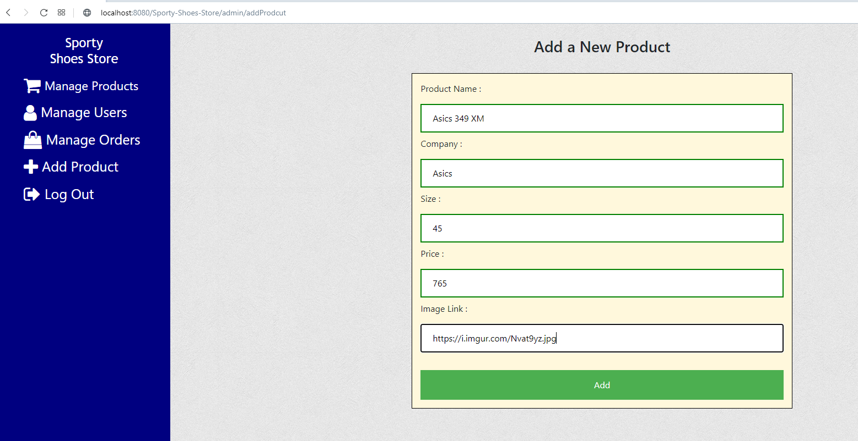

1. **Search a product by name :**

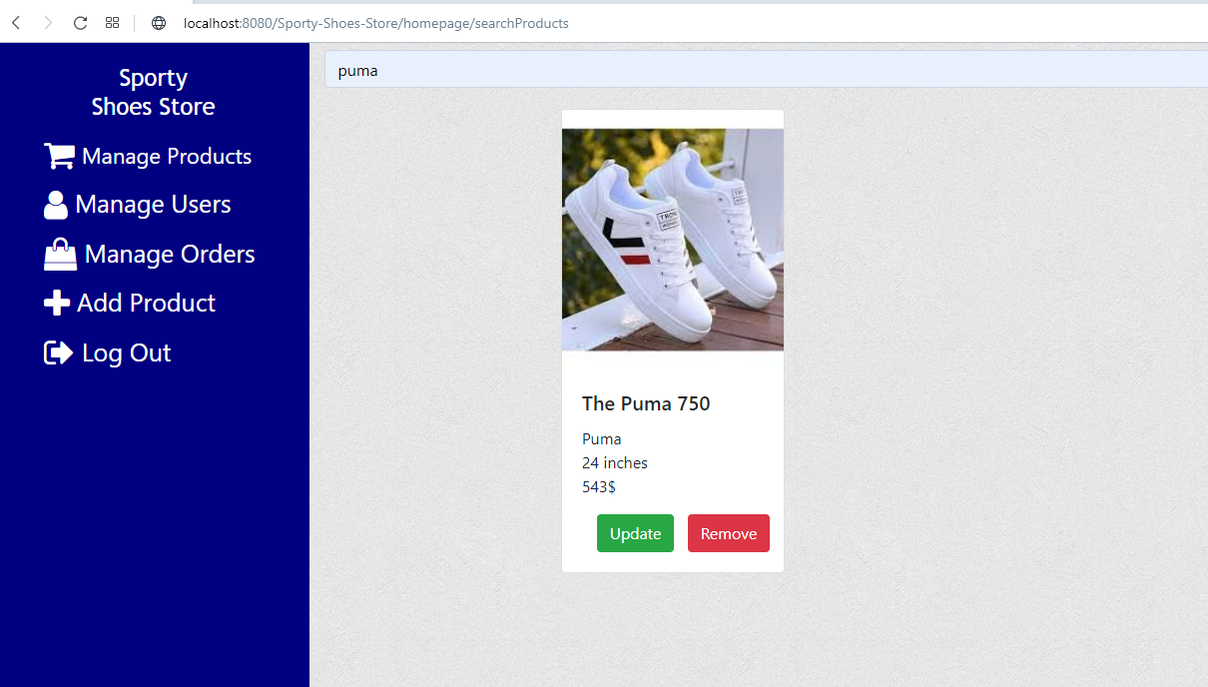

1. **Manage users page:**

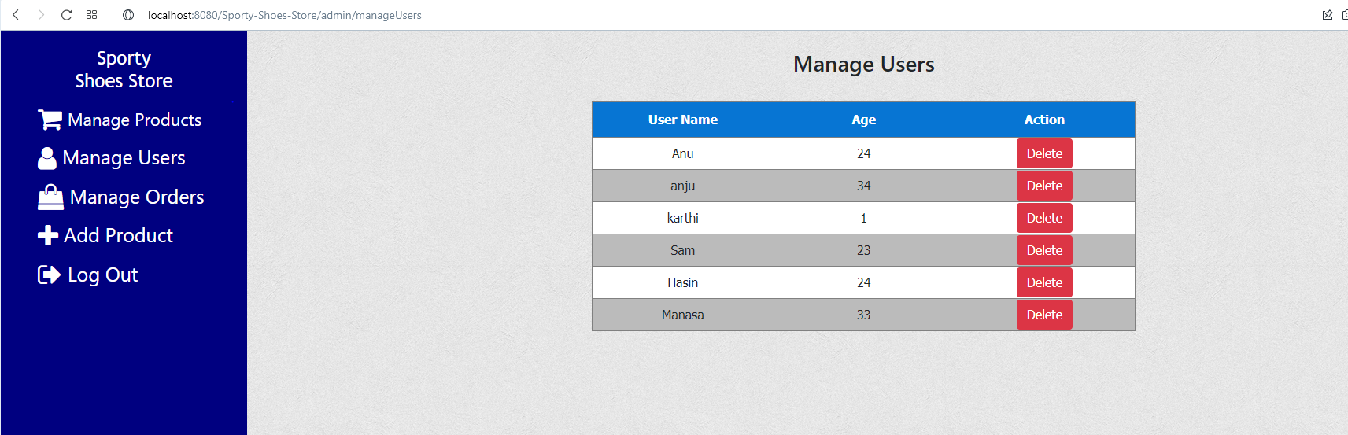

1. **Manage orders:**

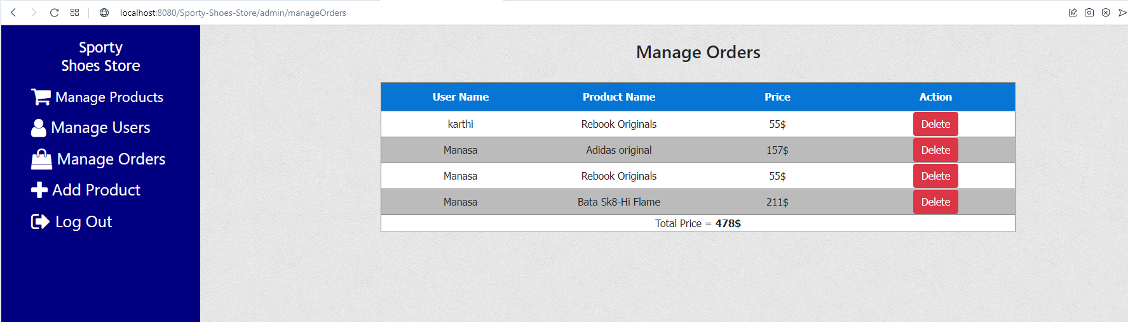

1. **Add a new products to the system.**

